# ASSIGNMENT IV

**Python Programming**

|  |  |
| --- | --- |
| Assignment Date | 25 October 2022 |
| Student Name | Rani praba.A |
| Student Roll Number | 912419106008 |
| Maximum Marks | 2 Marks |

# Question-1:

**Write code and connections in wokwi for ultrasonic sensor.**

**Whenever distance is less than 100 cms send "alert" to ibm cloud and display in device recent events.**

**Upload document with wokwi share link and images of ibm cloud**

# Solution:

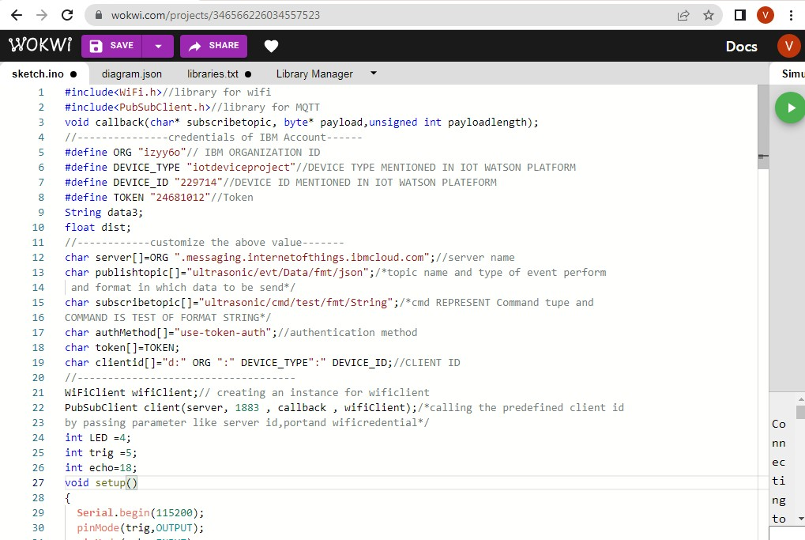

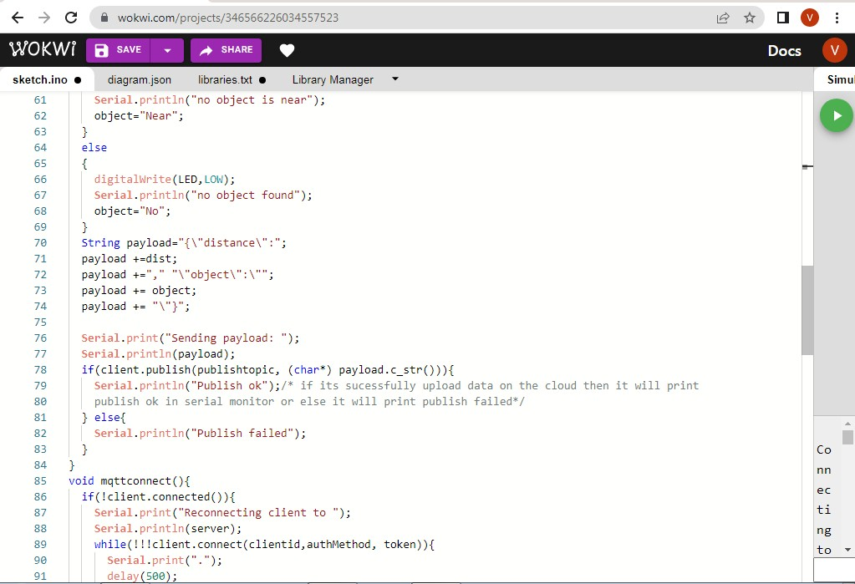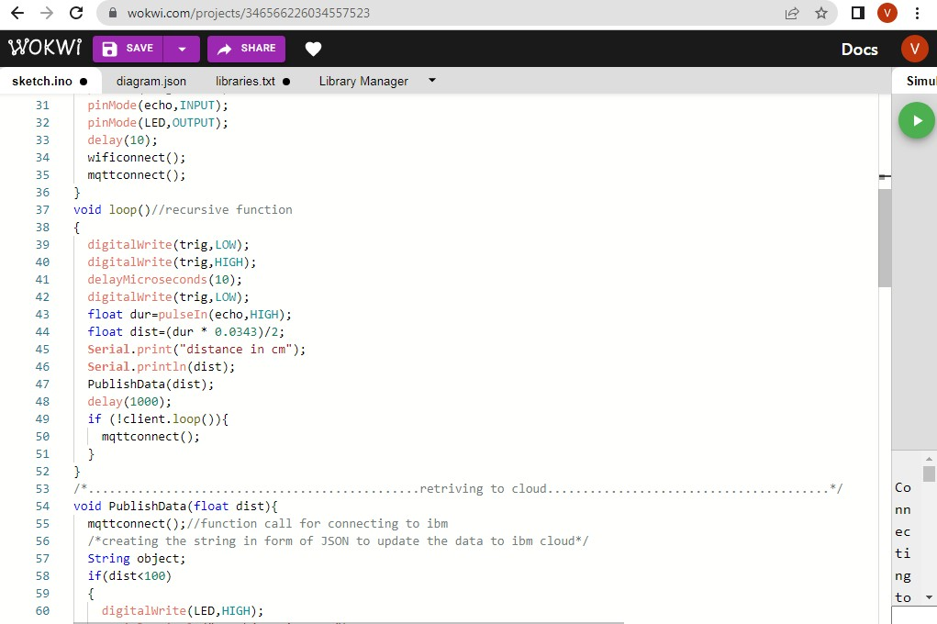

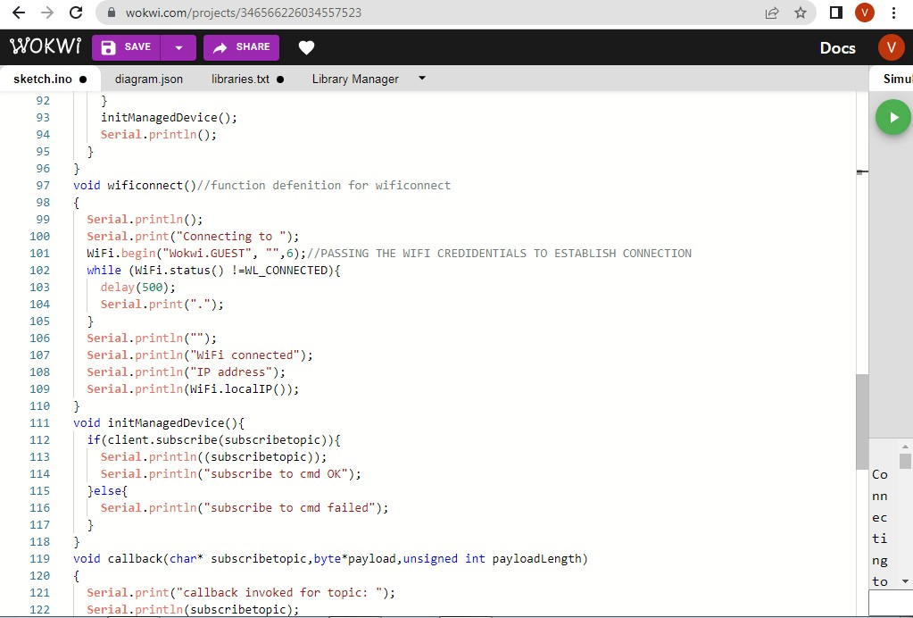

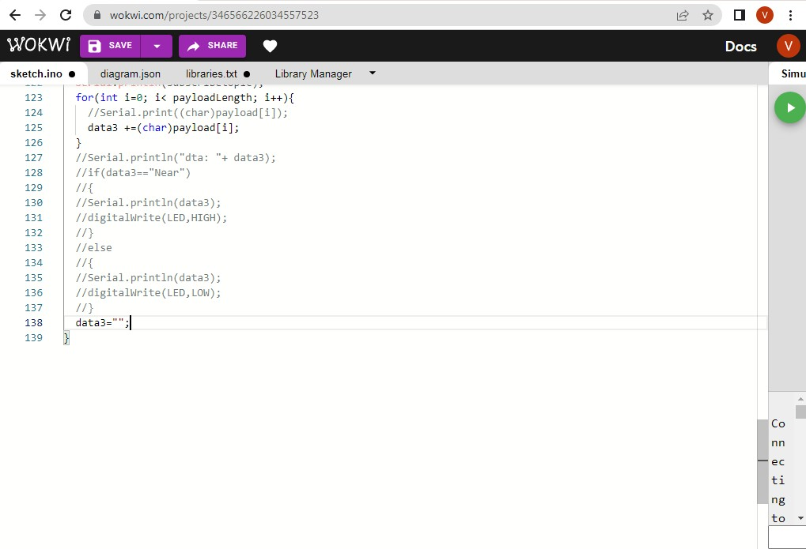

OUTPUT:

<https://wokwi.com/projects/346572482591851092>

DATA SENT TO IBM CLOUD ON NO OBJECT DETECTED

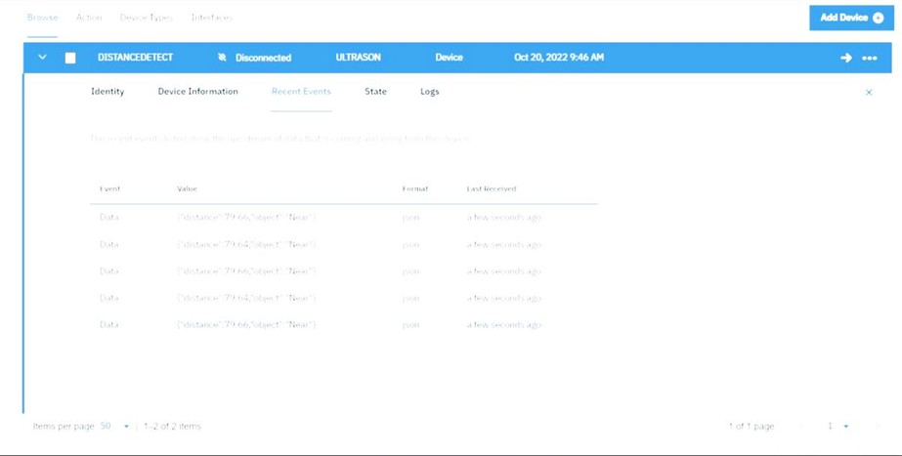

WHEN NO OBJECT DETECTED BY ULTRASONIC DETECTOR

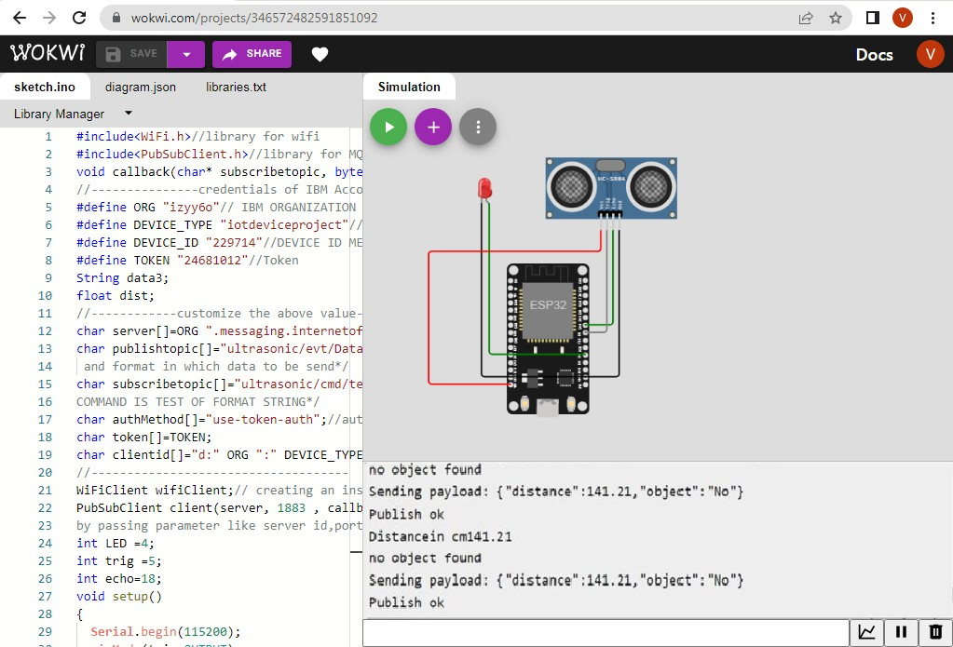

DATA SENT TO IBM CLOUD ON OBJECT BEING DETECTED



WHEN OBJECT DETECTED BY ULTRASONIC DETECTOR SENSOR

